Switch (case) Statement, used with serial input

An if statement allows you to choose between two discrete options, TRUE or FALSE. When there are more than two options, you can use multiple if statements, or you can use the [switch](https://www.arduino.cc/en/Reference/SwitchCase) statement. Switch allows you to choose between several discrete options.

This tutorial shows you how to use switch to turn on one of several different LEDs based on a byte of data received serially. The sketch listens for serial input, and turns on a different LED for the characters a, b, c, d, or e.

Hardware Required

* Arduino or Genuino Board
* 5 LEDs
* 5 220 ohm resistors
* hook-up wires
* breadboard

Circuit

Five LEDs are attached to digital pins 2, 3, 4, 5, and 6 in series through 220 ohm resistors.

To make this sketch work, your board must be connected to your computer. In the Arduino IDE open the serial monitor and send the characters a, b, c, d, or e to lit up the corresponding LED, or anything else to switch them off.

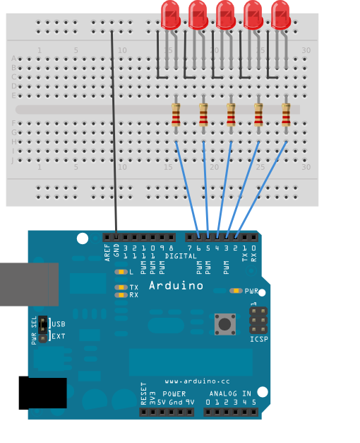

Schematic

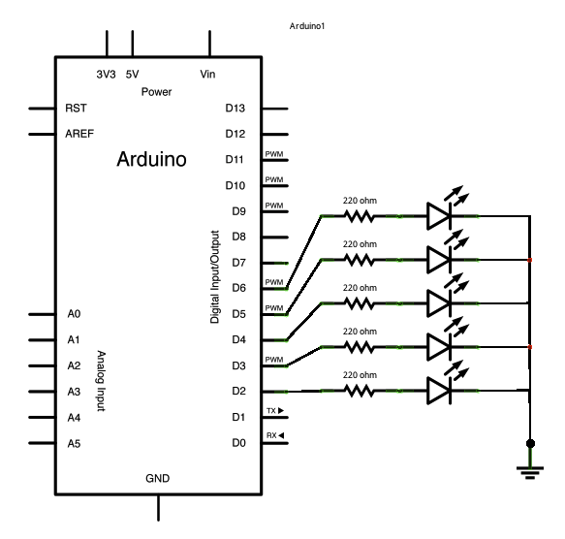

Code

void **setup**() {  
  *// initialize serial communication:*  
  Serial.begin(9600);  
  *// initialize the LED pins:*  
  for (int thisPin = 2; thisPin < 7; thisPin++) {  
    pinMode(thisPin, OUTPUT);  
  }  
}  
  
void **loop**() {  
  *// read the sensor:*  
  if (Serial.available() > 0) {  
    int inByte = Serial.read();  
    *// do something different depending on the character received.*  
    *// The switch statement expects single number values for each case; in this*  
    *// example, though, you're using single quotes to tell the controller to get*  
    *// the ASCII value for the character. For example 'a' = 97, 'b' = 98,*  
    *// and so forth:*  
  
    switch (inByte) {  
      case 'a':  
        digitalWrite(2, HIGH);  
        break;  
      case 'b':  
        digitalWrite(3, HIGH);  
        break;  
      case 'c':  
        digitalWrite(4, HIGH);  
        break;  
      case 'd':  
        digitalWrite(5, HIGH);  
        break;  
      case 'e':  
        digitalWrite(6, HIGH);  
        break;  
      default:  
        *// turn all the LEDs off:*  
        for (int thisPin = 2; thisPin < 7; thisPin++) {  
          digitalWrite(thisPin, LOW);  
        }  
    }  
  }  
}

|  |  |  |  |  |
| --- | --- | --- | --- | --- |
| Your full name | Tel. | Email | Group | Su23 |
| Nguyễn Xuân Trung | 0944353601 | [Trungnxqe170172@fpt.edu.vn](mailto:Trungnxqe170172@fpt.edu.vn) | 2 – SE17B02 |  |
| Đoàn Nguyễn Huyền Trang | 0344468198 | trangdnhqe170154@fpt.edu.vn |  |  |
| Phan Phương Sinh | 0522991730 | [Sinhppqe170242@fpt.edu.vn](mailto:Sinhppqe170242@fpt.edu.vn) |  |  |
| Nguyễn Đồng Lợi | 0702772499 | loindqe170249@fpt.edu.vn |  |  |
| Đường Mỹ Hà | 0901130650 | HaDMQE170046@fpt.edu.vn |  |  |
| Screen shot:    https://www.tinkercad.com/things/3Fl8IXrXze7-smooth-luulia-bigery/editel?sharecode=gsUhvxagrwRrbxsv0lrFRp7De-FI8BR9-j__yJhcCjM | | | | |
| How it works? | | | | |